Kliun, Ivan Vasilievich [b. Kliunkov]
Born ?? 1873 in Bolshiye Gorki, Vladimir Province, Imperial Russia
Died 13 December, 1943, Moscow, USSR

In attending the Fedor Rerberg Art Institute between 1903 and 1908, Ivan Kliun not only learned the laws of colour and light from a Russian Impressionist, he also met Kazimir Malevich, David Burliuk, Aleksei Morgunov and others. Together they were at the core of Russian avant-garde painters in Moscow. As with so many artists at the time, Kliun seems to have made a sudden leap into a combination of Cubism and Futurism in 1913. His works of 1914 are highly complex constructions in which a portrait head, a machine, or the turning wheels of a locomotive become decomposed Cubistically in order to reveal the repetitive sections of dynamic Futurist movement. It was also in 1914 that Kliun began an in-depth investigation into colour and this is the source of his non-objective painting from then on. Sharing ideas with Malevich, Kliun’s first Suprematist works were sculptures (1915), but from that year until the early 1930s his paintings were composed mainly with beams of light projected onto a screen. This painting of light was based on the laws of spectral, prismatic colours and organised by various geometrical structures. The works were non-objective and Kliun’s Suprematist enquiry into light was in the main stream of modernism since Impressionism.

Kliun’s earliest dated drawings and watercolours between 1900 and 1909 depict landscapes and still lifes, but from 1910 there are numerous Symbolist compositions influenced in particular by the work of Mikhail Vrubel. In his Cubo-Futurism Kliun was unique in the way he worked in two media – oil on canvas and a three-dimensional object made in wood – in the exploration of an object from multiple points of view (Cubism) and the dynamism inherent in these multiple points of view or, indeed, of objects that move such as a train (Futurism). An example of this cross-over between painting and wood constructions can be seen in Landscape Passing By (1914, former George Costakis Collection, Moscow), which exists in numerous versions and in several media. These works of 1914 are evidence of an investigation into dynamism through rhythmic structure expressed in planar shapes. That Kliun used projectors is confirmed in a text of the late 1920s, “Colour, Light, Sweetness...”, in which he writes: “If I shine another light through another opening in the wall” onto a screen, then depending on the position and adjusting of the lens, a light composition begins to appear.”

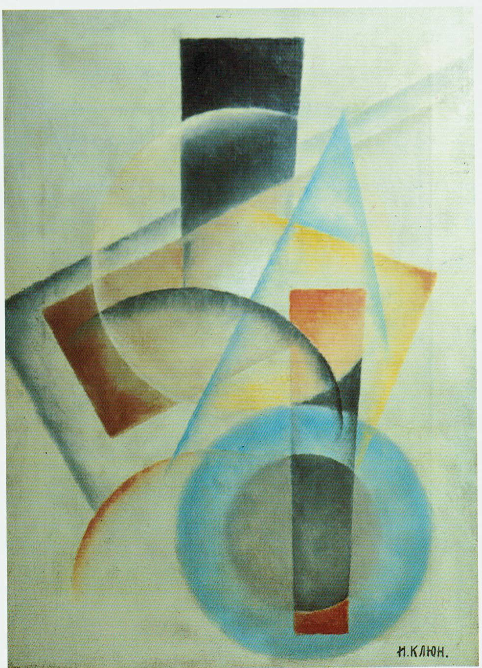
Suprematism, c. 1922. Oil on canvas, 61 x 43.5 cm. Private Collection

These light compositions varied between a single geometrical plane of colour (square, circle, rectangle, etc.) and complex arrangements of interpenetrating geometrical planes, from a dense colour to a limpid transparency. His colours obeyed the laws of spectral colours, while the complementary colours of light – red/green, orange/blue, yellow/violet – served to animate the works because they animate the observer’s eye. Due to Stalin’s 1932 decree making art an instrument of propaganda, Kliun returned to the realism of the portrait and the landscape. Yet among his last works is a colour chart dated 1942: “Regarding the Problem of Composition: Construction following Decorative and Organic Principals”. Kliun remained a colourist, and in his Suprematism, form manifests through light.

References and further reading:
The George Costakis Collection – Russian Avant-Garde Art, New York: Harry N. Abrams,
Inc., 1981, pp. 139-205.
Svetlana Kliundova-Soloveichik, Ivan Vasilievich Kliun. New York: IVK Art, 1994.
Light and Colour in the Russian Avant-Garde, Thessaloniki: The Costakis Collection from
the State Museum of Contemporary Art, 2004.

